 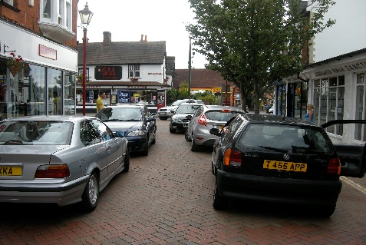

NEED A BETTER PLACE TO PARK?

Need extra short or long term parking? Too many cars, not enough space? Unable to park your car on the street? The City of Hailey has 32 paved parking spaces available for rent. The lot is easily accessible 24 hours a day on North River St. Rental terms are month to month at a cost of $50 per month, with the option to automatically renew.

Q & A:

Are the spaces covered? No, they are open spaces.

Are the spaces assigned? No, you can park in any available open space.

Where is the parking lot located? 111 Empty Saddle Trail, right next to the River Street Apartments.

Can I sign up for multiple months at a time? The online registration system requires month to month, but you can ask the Park Administrator to set you up for automatic renewal after you register.

Can I rent more than one space? Yes, absolutely.

Are there security cameras? No, but the lot will be patrolled by Hailey Police Department regularly.

What happens if people who are not registered park in the lot? They will be towed.

Can I park my boat, RV, trailer, or non-operational vehicle on the lot? No. The lot is for operational, regular passenger vehicles only. All vehicles must be insured and registered.

How is it decided who gets a space? Spaces are granted on a first come, first served basis after application approval.

How do I sign up? Go to: https://hailey.recdesk.com/Community Choose the Parking Rental tab, fill out the required information, and complete payment. You are all set!

You will receive an email 5 days before your monthly rental period ends.

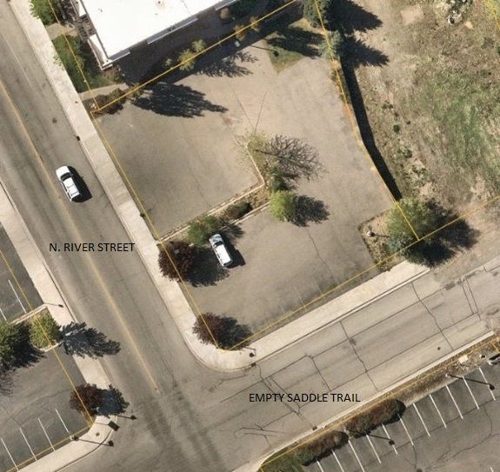

Feel free to contact me with any questions.

Amy Bain

Parks Administrator

208-471-8798

[Amy.bain@haileycityhall.org](mailto:Amy.bain@haileycityhall.org)

.